The Thyroid Gland and Thyroxine

The thyroid gland contains large numbers of thyroid follicles. Individual follicles are spheres lined by a simple cuboidal epithelium.
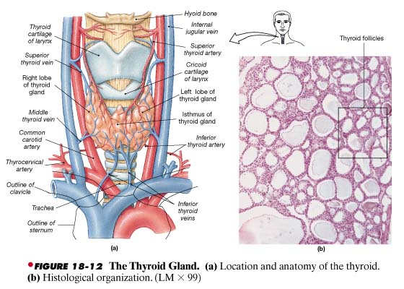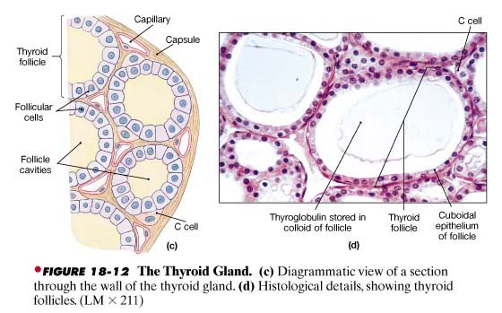

The hormone thyroxine, also known as tetraiodothyronine, or simply T₄, contains four iodide ions. Triiodothyronine, or T₃, is a related molecule containing three iodide ions.

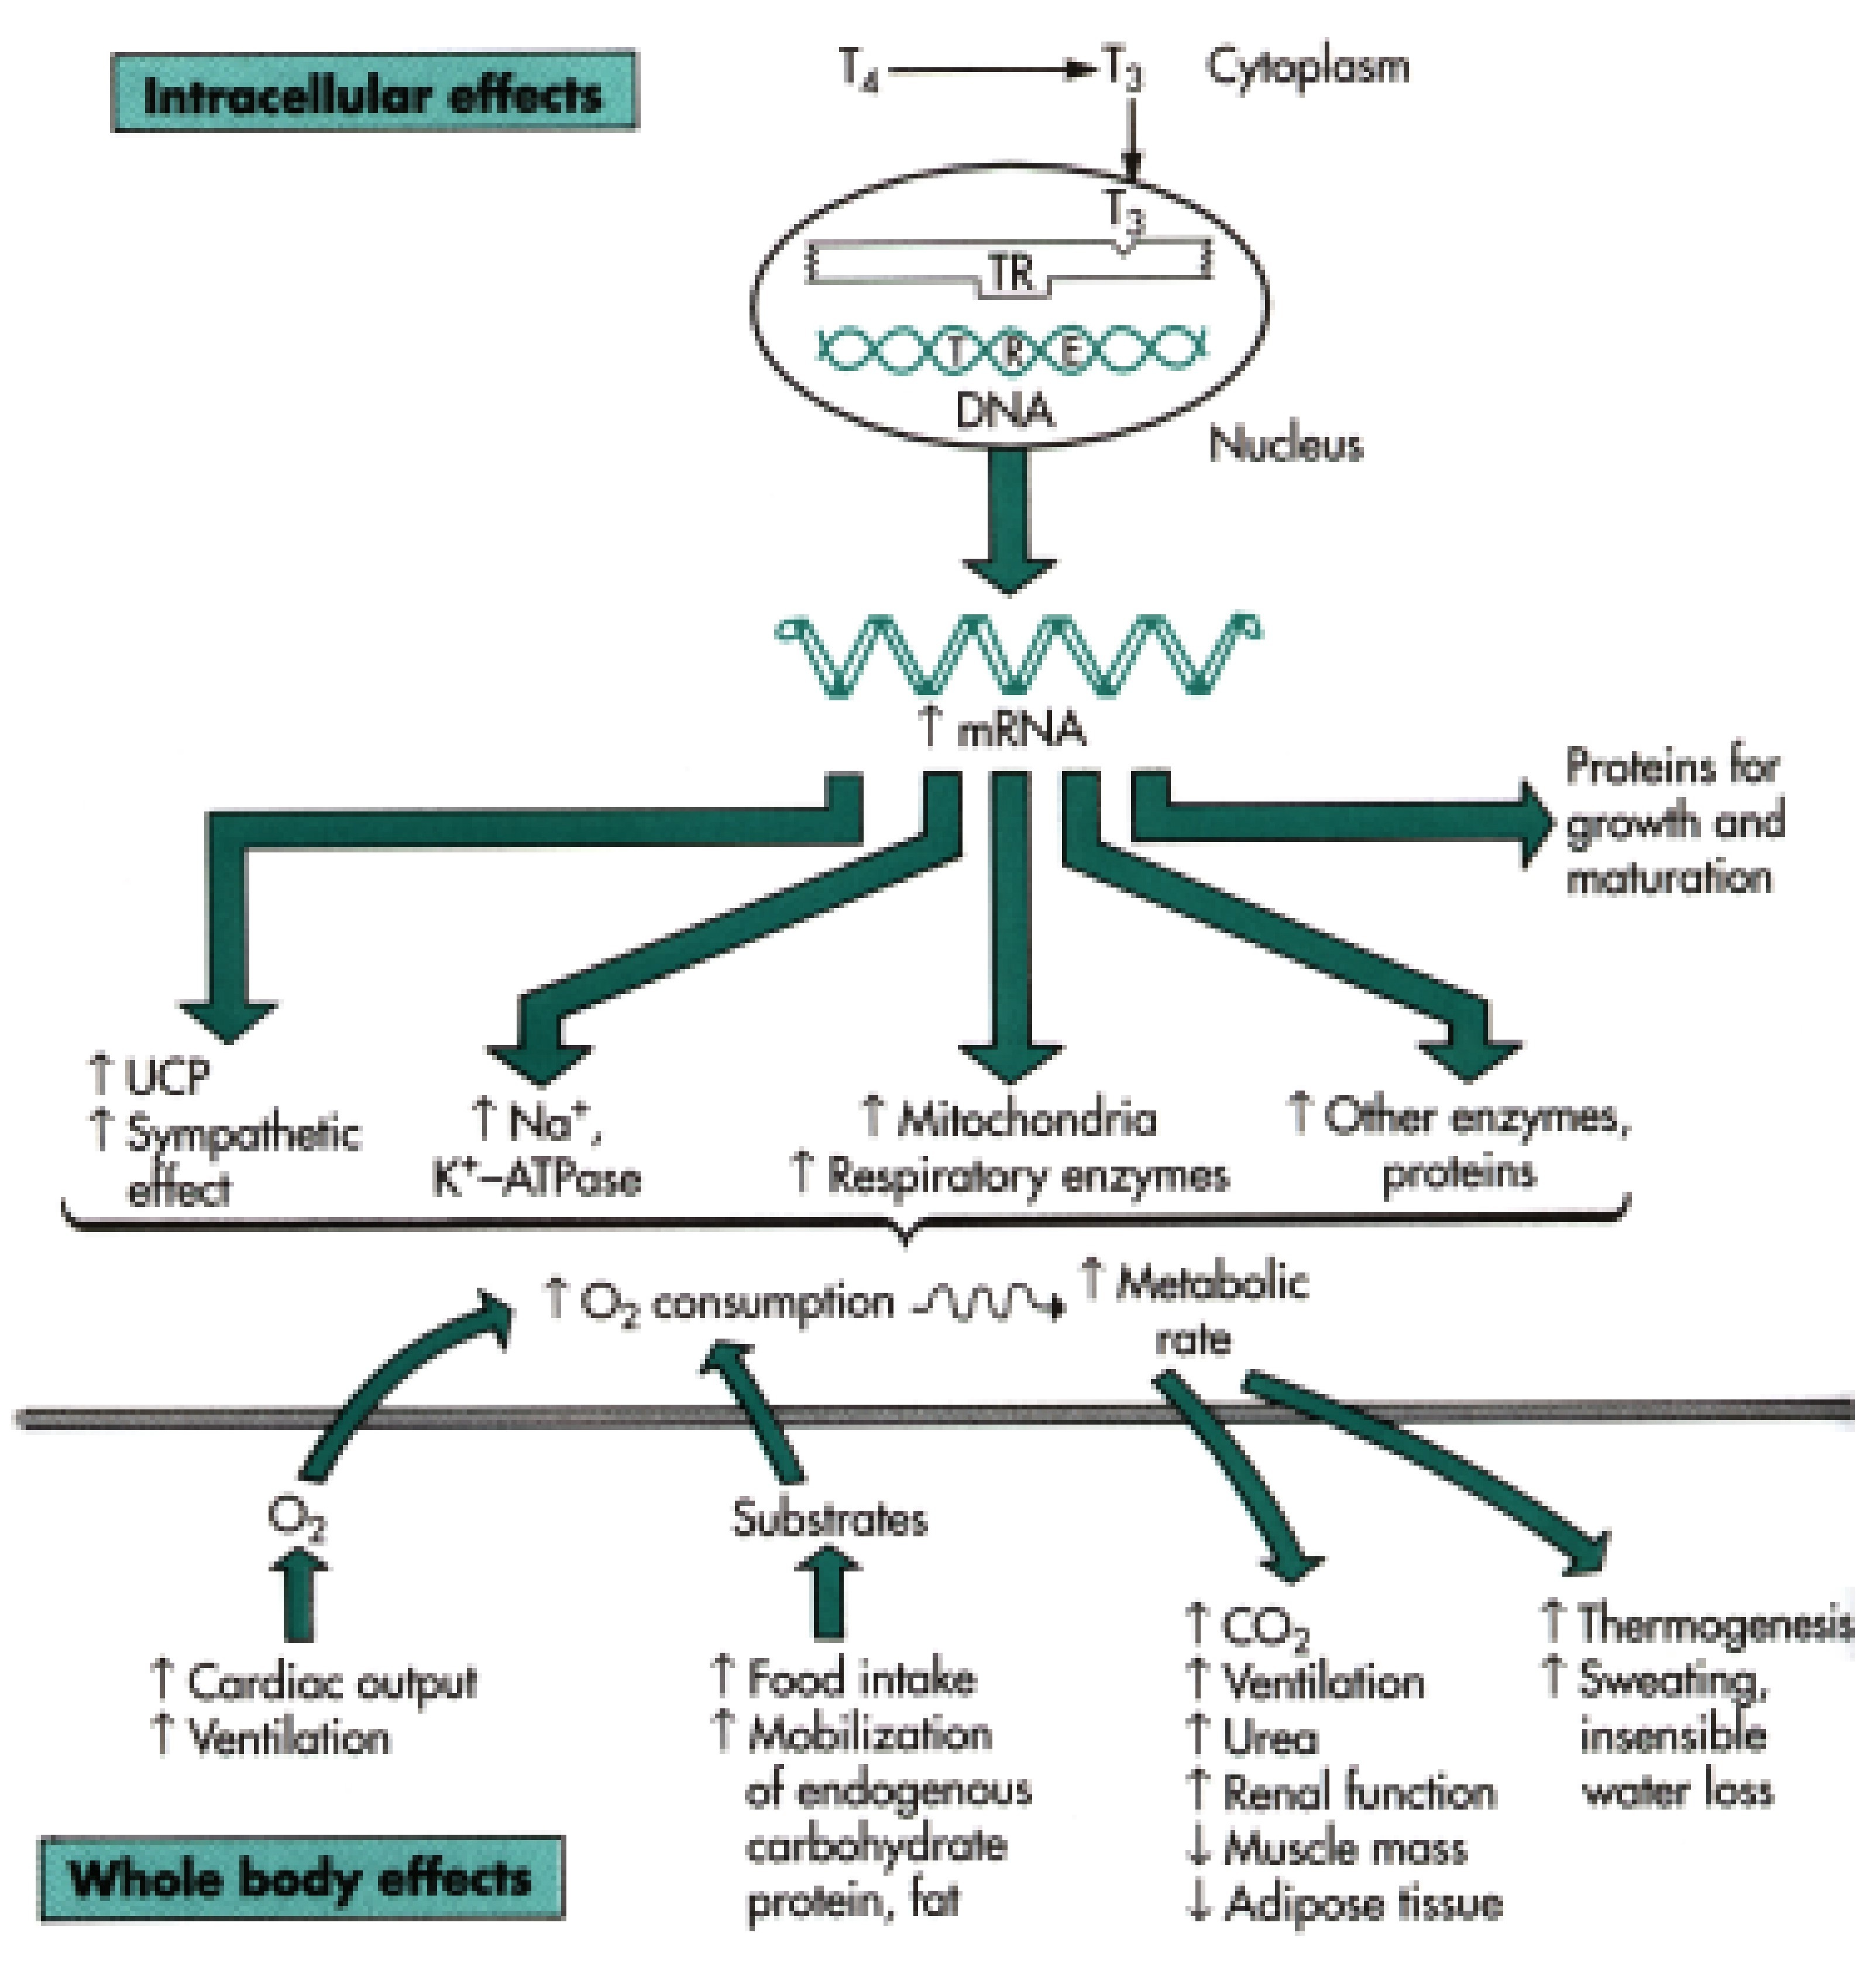
Functions of Thyroid Hormones

Thyroxine readily cross cell membranes, and they affect almost every cell in the body. Inside a cell, it binds to:
(1) receptors in the nucleus,
(2) receptors on the surfaces of mitochondria, and (3) receptors in the cytoplasm.

The thyroxine binds to mitochondria increase the rates of mitochondrial ATP production.

It also also activates genes that code for the synthesis of enzymes involved in glycolysis and ATP production. This effect, coupled with the direct effect on mitochondria, increases the metabolic rate of the cell.

Effects of Thyroid Hormones on Peripheral Tissues

1. Elevate oxygen consumption and energy consumption rate; in children, may cause a rise in body temperature
2. Increase heart rate and force of contraction; generally cause a rise in blood pressure
3. Increase sensitivity to sympathetic stimulation
4. Maintain normal sensitivity of respiratory centres to changes in oxygen and carbon dioxide concentrations
5. Stimulate formation of red blood cells and thereby enhance oxygen delivery
6. Stimulate activity of other endocrine tissues

Regulation of Thyroxine
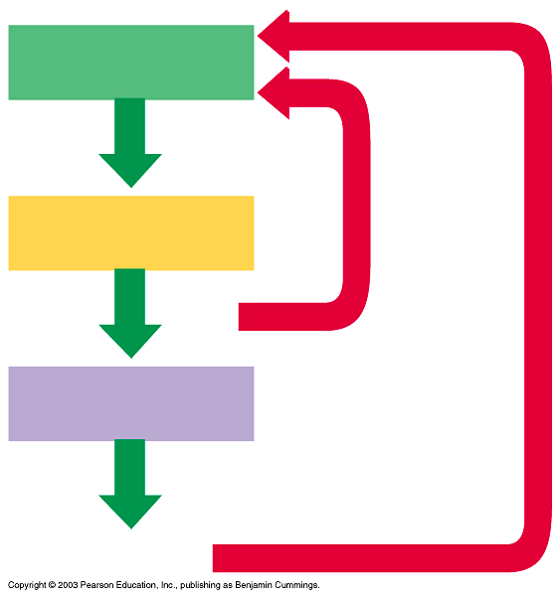
Hypothalamus
TRH
Anterior pituitary
TSH
Thyroid
Thyroxine
Inhibition

Hypothyroidism

Inadequate production of thyroxine or inadequate dietary iodide.

Hypothyroidism in infants produces a condition known as cretinism, marked by inadequate skeletal and nervous development and a metabolic rate as much as 40% below normal levels. Cretinism developing later in childhood will retard growth and mental development and delay puberty.

The symptoms of adult hypothyroidism include subcutaneous swelling, dry skin, hair loss, low body temperature, muscular weakness, slowed reflexes and a goitre. A goitre is an enlargement of the thyroid gland. The enlargement generally indicates increased follicular size, despite a decrease in the rate of thyroid hormone production. Most goitres develop when the thyroid gland is unable to synthesize and release adequate amounts of thyroid hormones. Under continuing TSH stimulation the thyroid follicles enlarge. One type of goitre occurs if the thyroid fails to obtain enough iodine.

The usual therapy involves the administration of thyroxine, which has a negative feedback effect on the hypothalamus and pituitary, inhibiting the production of TSH. Over time, the resting thyroid may return to its normal size.

Hyperthyroidism

Excessive production of thyroxine.

The metabolic rate climbs, and the skin becomes flushed and moist with perspiration. Blood pressure and heart rate increase, and the heartbeat may become irregular as circulatory demands escalate. The effects on the CNS make the individual restless, excitable, and subject to shifts in mood and emotional states. Despite the drive for increased activity, the person has limited energy reserves and fatigues easily. Graves' disease is a form of hyperthyroidism where excessive thyroid activity leads to goitre. Protrusion of the eyes may also appear.

Graves' disease has a genetic autoimmune basis and affects many more women than men. Treatment may involve the use of antithyroid drugs, surgical removal of portions of the glandular mass, or destruction of part of the gland by exposure to radioactive iodine.

Hyperthyroidism may also result from inflammation or, rarely, thyroid tumours. In extreme cases, the individual's metabolic processes accelerate out of control.

